EXPERIMENT-1

Consider following databases and draw ER diagram and convert entities and relationships to relation table for a given scenario:
COMPANY DATABASE:
EMPLOYEE (SSN, Name, Address, Sex, Salary, Super SSN, D No.) DEPARTMENT (D No., D Name, Mgr SSN, Mgr Start Date) DLOCATION (D Location)
PROJECT (P No., P Name, P Location, D No.) WORKING (SSN, P No., Hours Worked)
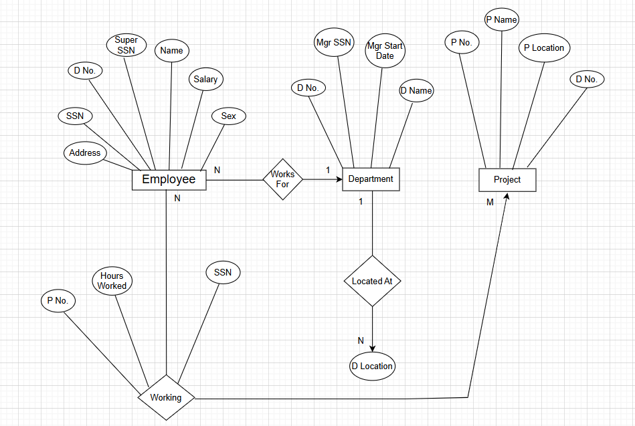

Explanation of ER Diagram – Company Database :

This ER diagram represents a company database that stores information about employees, departments, locations, and projects.

The Employee entity stores details such as SSN, name, address, sex, salary, supervisor SSN, and department number. Each employee works for a department. This relationship is shown using WORKS FOR. Many employees can work for one department, but each employee works for only one department.
The Department entity stores department information such as department number, department name, manager SSN, and manager start date. A department can have multiple locations. This is shown using the LOCATED AT relationship between Department and D Location.

The Project entity stores information about projects such as project number, project name, project location, and department number. Each project is controlled by one department, and one department can control many projects.

- Employees work on different projects. This many-to-many relationship is shown using the WORKS ON relationship. The number of hours an employee works on a project is stored as an attribute of this relationship.
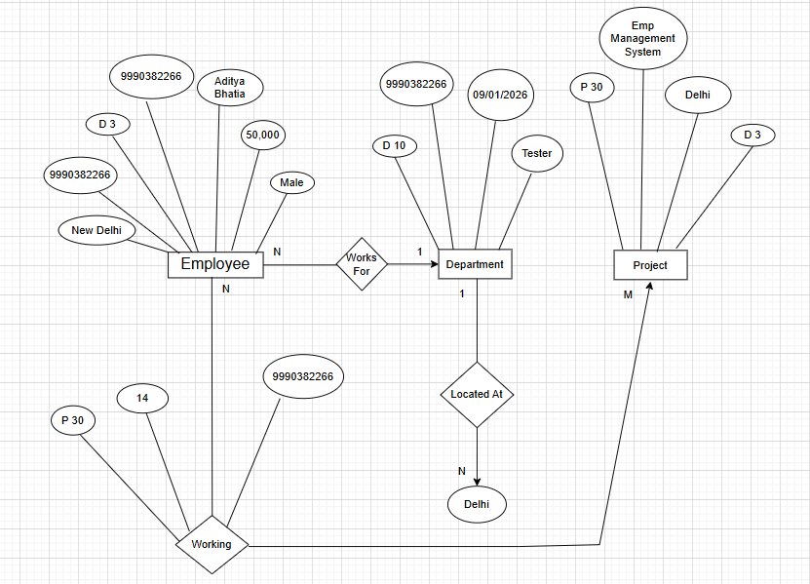

Company ER Diagram Explained Using Real Example :
The ER diagram consists of three main entities: Employee, Department, and Project. Employees work for departments through the Works For relationship (N:1). Departments are located at specific places through the Located At relationship. Departments manage multiple projects (1:M). Employees work on projects through the Working relationship, which stores additional attributes such as working hours, forming an M:N relationship.

EXPERIMENT-2

Consider following databases and draw ER diagram and convert entities and relationships to relation table for a given scenario:

COLLEGE DATABASE:
STUDENT (USN, S Name, Address, Phone, Gender) SEMSEC (SSID, Sem, SEC)
CLASS (USN, SSID)
SUBJECT (Code, Name, Sem, Credits)
IAMARKS (Test1, Test2, Test3, FinalIA)
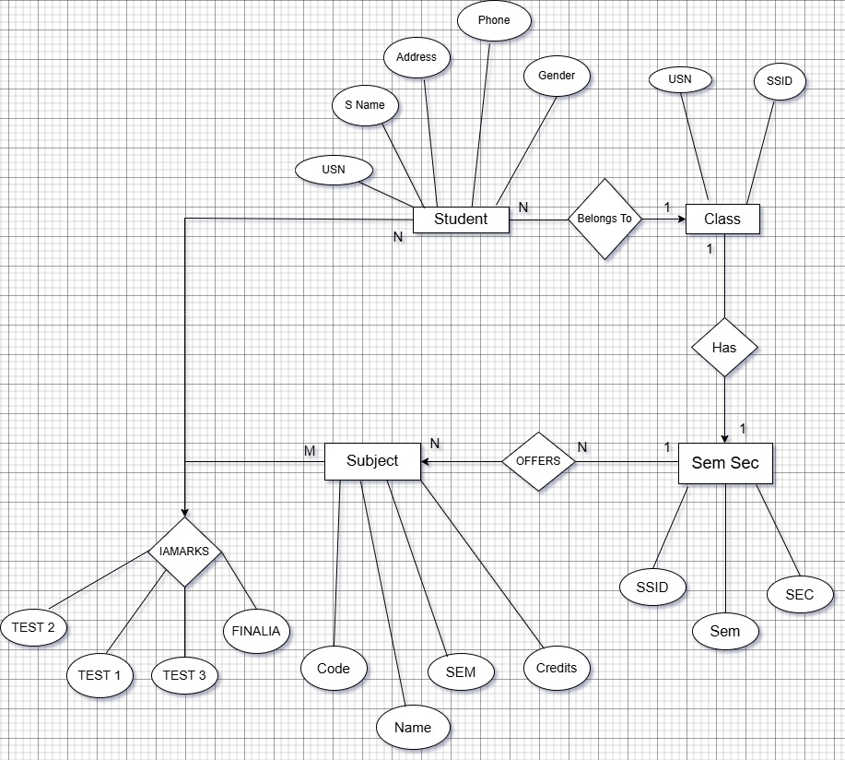

Explanation of ER Diagram – College Database :

- This ER diagram represents a college database that stores information about students, classes, semester–sections, subjects, and internal assessment marks.

- In this diagram, the Student entity stores the basic details of a student such as USN, student name, address, phone number, and gender. Every student belongs to a particular class. This relationship is shown using the BELONGS TO relationship. Many students can belong to the same class, but a student can belong to only one class.

- The Class entity represents a group of students. Each class is associated with exactly one semester and section, which is represented by the SemSec entity. The relationship between Class and SemSec is one-to-one, meaning each class has only one semester-section and each semester-section belongs to one class.

- The SemSec entity stores information about the semester and section. A semester-section offers multiple subjects. This is shown by the OFFERS relationship between SemSec and Subject. One semester-section can offer many subjects, but each subject is offered in one specific semester-section.

- The Subject entity stores subject details such as subject code, subject name, semester, and credits. Students study multiple subjects, and each subject is studied by many students. This many-to-many relationship is represented using the IAMARKS relationship.

- The IAMARKS relationship stores the internal assessment marks of students for each subject. It includes Test1, Test2, Test3, and Final IA. This relationship connects Student and Subject and stores marks for every student–subject combination.

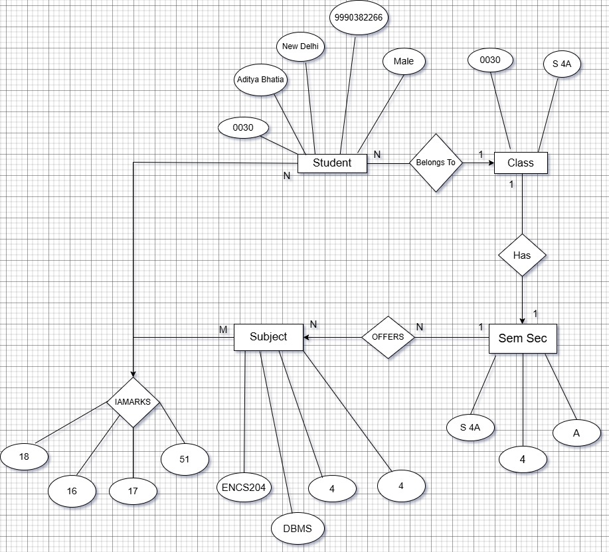

College ER Diagram Explained Using Real Example :
- Consider a student named Aditya Bhatia whose USN is 0030. He lives in New Delhi, his phone number is 9990382266, and his gender is Male. Aditya belongs to a class named S4A, which is associated with semester 4 and sectionA.

- The Class S4A is linked with one Semester–Section entity that stores the details of semester 4 and section A. This shows that each class is associated with exactly one semester and section.

- In semester 4, several subjects are offered. One of the subjects is DBMS with subject code ENS204, semester 4, and 4 credits. Aditya studies DBMS along with other subjects. This information is represented using the OFFERS relationship between SemSec and Subject.

- Aditya’s internal assessment marks in DBMS are Test1 = 18, Test2 = 16, Test3 = 17, and Final IA = 51. These marks are stored in the IAMARKS relationship, which connects the Student entity to the Subject entity and records the marks for each student–subject combination.

